The farther a curve is zoomed in, the closer to a line it looks, justifying methods of approximating the value of $x$ by using a line. This section shows how to calculate relative errors from such a *linear approximation*.

# Linear Approximations

Linear Approximation, Tangent Line Approximation, Linearization (*object*) – a line that approximates values of $y$ for values of $x$ near a certain domain value $a$.

Given a function $f\left(x\right)=y$, the linearization of $f$ at $a$ would be $L\left(x\right)=f\left(a\right)+f^{'}\left(a\right)\left(x-a\right)$. Figure 1 illustrates this.

Notice that as $x$ approaches $a$, $L\left(x\right)$ approaches $f\left(x\right)$.

Figure

# Differentials

Differential (*object*) – a measure of change (difference) in a variable. Examples: $dx$, $dy$, $dV$. See Figure 2.

Figure

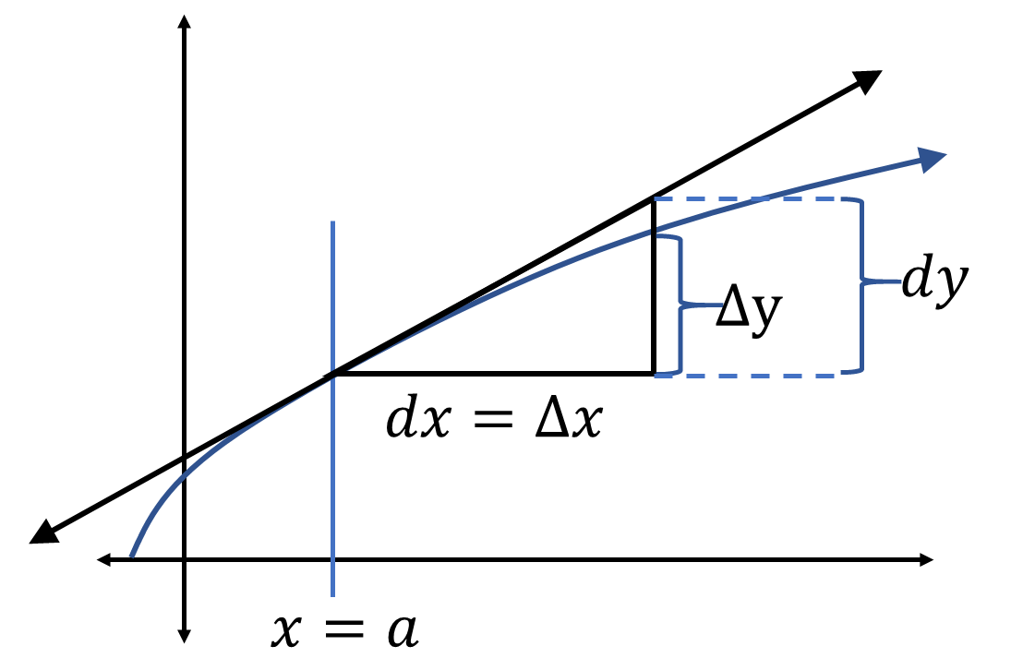The past sections have put differentials into ratios to define $f^{'}$. Now, separating them with algebra:

$$\frac{dy}{dx}=f^{'}\left(x\right)$$

Therefore,

$$dy=f^{'}\left(x\right)dx$$

Put into a triangle, $dy$ is the change in the linearization, but $Δy$ is the change in the curve. Figure 3 diagrams this.

Figure

Since and $\lim_{Δx→0}{Δy}=dy$, then $dy$ can be a measurement of possible error given a known $dx$ that means the error possible of $x$.

Relative error (*measure*) – the possible error in a variable divided by the variable.

Percentage error (*measure*) – the relative error expressed as a percentage.

# What Did You Learn?

* What is a linearization of a function?
* How do derivatives define linear approximations?
* Why does $dy$ measure possible error for a given possible error of $dx$?